|  |
| --- |
| 1744 |
| Pacific Pines State School |
| ANNUAL REPORT |
| 2018 |
| Queensland State School Reporting |
| Every student succeeding  State Schools Strategy  Department of Education |

|  |
| --- |
| Contact information |
|  |

|  |  |
| --- | --- |
| Postal address | PO Box 534 Helensvale 4212 |
| Phone | (07) 5502 5333 |
| Fax | (07) 5502 5300 |
| Email | principal@pacificpinesss.eq.edu.au |
| Webpages | Additional information about Queensland state schools is located on:   * the [*My School*](http://www.myschool.edu.au/) website * the [Queensland Government data](http://data.qld.gov.au/) website * the Queensland Government [schools directory](https://schoolsdirectory.eq.edu.au/) website. |
| Contact person | Scott Anderson (Principal) |

|  |
| --- |
| From the Principal |
|  |

School overview

Pacific Pines State School provides a quality education for children from Prep to Year 6. Our school vision, We do ‘whatever it takes’ so our students become the best they can be, is the driver of the work we do as a learning organization. As a school we do ‘whatever it takes’ to ensure our students are successful in academic, sporting, artistic and cultural fields. We strive to improve on the quality of education through strategies that encourage improvement in every student. Our school delivers curriculum in an environment that is both supportive and challenging. We hold high expectations for our students in their both schoolwork and behaviour. These expectations are complemented by our school values that guide our actions and behaviours. Our values: Be Safe, Be Respectful, Be Responsible and Be a Learner are shared across our school community and are evident throughout our school.

School progress towards its goals in 2018

Our school Improvement Priorities in 2018 were:

Priority Area 1: Implement a consistent whole school reading framework to improve reading strategies and comprehension for all students

Priority Area 2: Continually improve student outcomes and pedagogical practice through cycles of inquiry

Priority Area 3: Implement a consistent Whole School Pedagogical Framework with a focus on Explicit Teaching.

Pacific Pines SS made significant progress with all priority areas in 2018 with a school reading framework embedded across all classrooms, all teachers using cycles of inquiry to improve practice and the development of a whole school pedagogical framework.

Future outlook

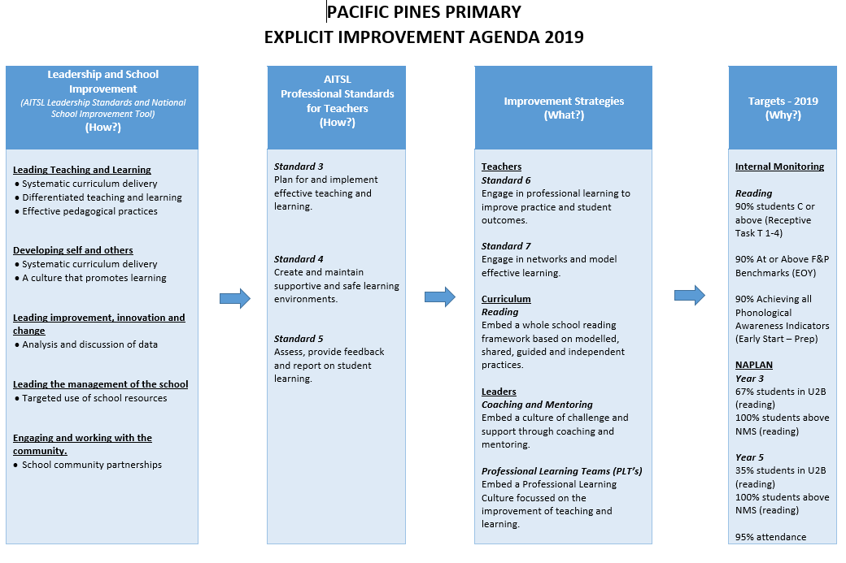

|  |
| --- |
| Our school at a glance |
|  |

School profile

|  |  |  |  |  |
| --- | --- | --- | --- | --- |
| Coeducational or single sex | Coeducational | | | |
| Independent public school | No | | | |
| Year levels offered in 2018 | Prep Year - Year 6 | | | |
| Student enrolments |  | | | |
| Table 1: Student enrolments at this school |  | | | |
| Enrolment category | 2016 | 2017 | 2018 | Notes:  1. Student counts are based on the Census (August) enrolment collection.  2. Indigenous refers to Aboriginal and Torres Strait Islander people of Australia.  3. [pre-Prep](https://earlychildhood.qld.gov.au/early-years/kindergarten-programs/kindergarten-in-indigenous-communities) is a kindergarten program for Aboriginal and Torres Strait Islander children, living in 35 Aboriginal and Torres Strait Islander communities, in the year before school. |
| Total | 935 | 947 | 975 |
| Girls | 477 | 475 | 489 |
| Boys | 458 | 472 | 486 |
| Indigenous | 18 | 19 | 13 |
| Enrolment continuity (Feb. – Nov.) | 96% | 95% | 95% |

In 2018, there were no students enrolled in a pre-Prep program.

Characteristics of the student body

Overview

Pacific Pines Primary School is a satellite urban suburb servicing the areas of Pacific Pines and Gaven. The area was first developed by Stocklands approximately 18 years ago and has mushroomed into a large residential area comprising four primary schools and one high school. The area around the school is comprised mostly of houses. Four large rental complexes are located within walking distance from the school.

Many students emanate from New Zealand and there has been an influx of migrants from Great Britain. New enrolments are constant throughout the year. Continuity of enrolments is quite high. 2% of the student enrolment is comprised of indigenous students and less than 2% of students are classified as having English as a second language.

The Pacific Pines area is predominantly populated by families whose parents work in the trade or service industries. Most families have two parents with a significant number of those families having only one parent employed. The school has a number of parent and grandparent volunteers assisting with Home Readers and in classrooms.

Average class sizes

Table 2: Average class size information for each phase of schooling

|  |  |  |  |  |
| --- | --- | --- | --- | --- |
| Phase of schooling | 2016 | 2017 | 2018 | Note:  The [class size](https://qed.qld.gov.au/publications/reports/statistics/schooling/schools) targets for composite classes are informed by the relevant year level target. Where composite classes exist across cohorts (e.g. year 3/4) the class size targets would be the lower cohort target. |
| Prep – Year 3 | 23 | 23 | 24 |
| Year 4 – Year 6 | 27 | 25 | 26 |
| Year 7 – Year 10 |  |  |  |
| Year 11 – Year 12 |  |  |  |

Curriculum delivery

Our approach to curriculum delivery

Our focus is on building knowledge and skills in literacy and numeracy which is delivered through a systematic combination of explicit and direct instruction. With mastery of these learning areas, students are then given opportunities to develop higher order thinking skills. Differentiation of curriculum is a key feature of our curriculum design and is enhanced through our extensive range of technological tools.

Our distinctive curriculum offerings:

★ Our curriculum is based on the Australian Curriculum for English, Maths, Science, History Geography , The Arts , Health and Technology.

★ Japanese for students P- 6.

★ Japanese excellence class.

★ We have strong instrumental music (strings and band) and choral programs for students in years 3-6.

★ Ongoing partnership with Pacific Pines State High School.

★ Multilit intervention from P-3.

★ Year 5/6 Elective Program.

★Age Appropriate Pedagogies (P-1).

Co-curricular activities

★Chess Club after school

★ Senior school Electives program

★Before and after school sport’s training

★Robotics Club before and after school

★Choir (Junior and Senior)

★Strings and Band (Years 3-6)

★Dance Club

★Robotics

★Readers’ Cup

★Chess

★Griffith University Science Competition

★Homework Club before school

★STRIVE for identified students working at a higher juncture in their learn

How information and communication technologies are used to assist learning

In 2018 Pacific Pines Primary had 16 MyPad classes across the school. Students in these classes bring their own iPad to school to enhance their learning and increase creativity and communication about their learning with parents with flexible furniture allowing collaboration and group work among students. These classes are flexible learning environments All other classes have a bank of iPads in their rooms for students to access. This program will continue and expand in 2019.

All classes in year 4-6 had access to a bank of laptop computers per teaching block allowing on to one access for classes. The access to the one to one lab was enhanced as the labs were only for use by Prep to Year 3 classes due to the laptop program. Ipads and laptops were also purchased for classroom use in the lower grades. Our school also has two fully equipped computer laboratories.

Social climate

Overview

Pacific Pines Primary strives to create and develop a caring and inclusive educational environment for individuals through an enthusiastic, professional commitment to excellence, which reflects a genuine love of and care for students.

Our School Wide Positive Behaviour Plan focuses on developing a supportive school environment and responsible, positive behaviour in all students and staff. The Plan provides a framework for creating an environment for each learner to develop responsible self-management, whilst learning about how and why people behave the way they do. The framework encourages students, staff and community members to critically reflect on behaviour, problem solve and develop strategies to support individuals to become socially responsible citizens. The school is child-centred and student opinion is highly valued.

Pacific Pines Primary has developed a positive reputation in both the local and wider community, for our high expectations of students and for our intentionally inviting environment. The multicultural enrolment at our school develops our students’ racial, ethnic and cultural understanding and tolerance, as well as enriching our learning activities and experiences with input from other cultures.

Parent, student and staff satisfaction

Tables 3–5 show selected items from the Parent/Caregiver, Student and Staff School Opinion Surveys.

Table 3: Parent opinion survey

| Percentage of parents/caregivers who agree# that: | 2016 | 2017 | 2018 |
| --- | --- | --- | --- |
| * their child is getting a good education at school (S2016) | 93% | 100% | 97% |
| * this is a good school (S2035) | 93% | 100% | 97% |
| * their child likes being at this school* (S2001) | 97% | 100% | 100% |
| * their child feels safe at this school* (S2002) | 97% | 100% | 100% |
| * their child's learning needs are being met at this school* (S2003) | 93% | 97% | 95% |
| * their child is making good progress at this school* (S2004) | 92% | 97% | 93% |
| * teachers at this school expect their child to do his or her best* (S2005) | 95% | 100% | 98% |
| * teachers at this school provide their child with useful feedback about his or her school work* (S2006) | 85% | 95% | 92% |
| * teachers at this school motivate their child to learn* (S2007) | 93% | 100% | 95% |
| * teachers at this school treat students fairly* (S2008) | 88% | 95% | 90% |
| * they can talk to their child's teachers about their concerns* (S2009) | 93% | 98% | 92% |
| * this school works with them to support their child's learning* (S2010) | 92% | 97% | 90% |
| * this school takes parents' opinions seriously* (S2011) | 89% | 92% | 82% |
| * student behaviour is well managed at this school* (S2012) | 89% | 92% | 92% |
| * this school looks for ways to improve* (S2013) | 97% | 95% | 90% |
| * this school is well maintained* (S2014) | 95% | 97% | 94% |
| * Nationally agreed student and parent/caregiver items.  # ‘Agree’ represents the percentage of respondents who Somewhat Agree, Agree or Strongly Agree with the statement.  DW = Data withheld to ensure confidentiality. | | | |

Table 4: Student opinion survey

| Percentage of students who agree# that: | 2016 | 2017 | 2018 |
| --- | --- | --- | --- |
| * they are getting a good education at school (S2048) | 98% | 99% | 98% |
| * they like being at their school* (S2036) | 94% | 96% | 96% |
| * they feel safe at their school* (S2037) | 98% | 98% | 97% |
| * their teachers motivate them to learn* (S2038) | 100% | 99% | 94% |
| * their teachers expect them to do their best* (S2039) | 100% | 100% | 99% |
| * their teachers provide them with useful feedback about their school work* (S2040) | 99% | 98% | 95% |
| * teachers treat students fairly at their school* (S2041) | 95% | 92% | 88% |
| * they can talk to their teachers about their concerns* (S2042) | 95% | 91% | 88% |
| * their school takes students' opinions seriously* (S2043) | 90% | 91% | 90% |
| * student behaviour is well managed at their school* (S2044) | 82% | 80% | 81% |
| * their school looks for ways to improve* (S2045) | 98% | 98% | 97% |
| * their school is well maintained* (S2046) | 98% | 97% | 97% |
| * their school gives them opportunities to do interesting things* (S2047) | 97% | 98% | 100% |
| * Nationally agreed student and parent/caregiver items.  # ‘Agree’ represents the percentage of respondents who Somewhat Agree, Agree or Strongly Agree with the statement.  DW = Data withheld to ensure confidentiality. | | | |

Table 5: Staff opinion survey

| Percentage of school staff who agree# that: | 2016 | 2017 | 2018 |
| --- | --- | --- | --- |
| * they enjoy working at their school (S2069) | 90% | 98% | 98% |
| * they feel that their school is a safe place in which to work (S2070) | 100% | 98% | 96% |
| * they receive useful feedback about their work at their school (S2071) | 87% | 79% | 90% |
| * they feel confident embedding Aboriginal and Torres Strait Islander perspectives across the learning areas (S2114) | 83% | 84% | 79% |
| * students are encouraged to do their best at their school (S2072) | 100% | 100% | 98% |
| * students are treated fairly at their school (S2073) | 98% | 98% | 96% |
| * student behaviour is well managed at their school (S2074) | 98% | 98% | 96% |
| * staff are well supported at their school (S2075) | 88% | 92% | 81% |
| * their school takes staff opinions seriously (S2076) | 98% | 87% | 72% |
| * their school looks for ways to improve (S2077) | 98% | 100% | 100% |
| * their school is well maintained (S2078) | 98% | 92% | 94% |
| * their school gives them opportunities to do interesting things (S2079) | 89% | 89% | 92% |
| * Nationally agreed student and parent/caregiver items.  # ‘Agree’ represents the percentage of respondents who Somewhat Agree, Agree or Strongly Agree with the statement.  DW = Data withheld to ensure confidentiality. | | | |

Parent and community engagement

Pacific Pines Primary has an "Open Door" policy and welcomes parental involvement. 2018 again saw many enthusiastic parents, grandparents and community members actively participating in school activities and in their child's education. The partnership between the school and the home, working together to support the child’s learning and behaviour is highly valued by staff. All members of the school community support the school’s high expectations and standards in providing a safe, caring and inclusive environment for all.

Regular communication through the school newsletter year level newsletters and Facebook page informs the school community of school events and invites participation in school and class activities. A term calendar for parents in each year level is sent home at the beginning of each term.

Meet the teacher parent information sessions early in the year establish relationships and communicate learning, behavioural and homework expectations; class routines and procedures; code of responsible student behaviour; curriculum and how parents may support their child in their learning. At other times parent information letters outline the core learning, unit of work focus and special events. Culminating units of work showcase student learning with special class and year level events strongly supported and valued by parents, guardians and grandparents.

Parent teacher interviews and end of semester reporting inform parents of student progress and further build on the parent teacher partnership. Parent volunteer support in the classrooms, on excursions and for events was well supported and appreciated by class and specialist teachers. A growing number of parent and community volunteers continue to assist the learning support and intervention programs

Respectful relationships education programs

The school has developed and implemented a program/or programs that focus on appropriate, respectful, equitable and healthy relationships. We utilize Life Education and Queensland Health to deliver programs to all of our students.

School disciplinary absences

Table 6: Count of incidents for students recommended for school disciplinary absences at this school

|  |  |  |  |  |
| --- | --- | --- | --- | --- |
| Type of school disciplinary absence | 2016 | 2017 | 2018 | Note:  School disciplinary absences (SDAs) are absences enforced by a school for student conduct that is prejudicial to the good order and management of the school. |
| Short suspensions – 1 to 10 days | 47 | 39 | 33 |
| Long suspensions – 11 to 20days | 0 | 0 | 2 |
| Exclusions | 1 | 0 | 0 |
| Cancellations of enrolment | 0 | 0 | 0 |

Environmental footprint

Reducing this school’s environmental footprint

Our staff and students are very conscious of the need to reduce our environmental footprint. Solar panels and water tanks have been installed. All appliances are turned off when not in use. Students and staff are educated regularly on proper use of electricity and water management.

Table 7: Environmental footprint indicators for this school

| Utility category | 2015–2016 | 2016–2017 | 2017–2018 | Note:  Consumption data is compiled from sources including ERM, Ergon reports and utilities data entered into OneSchool* by schools. The data provides an indication of the consumption trend in each of the utility categories which impact on this school’s environmental footprint.  *OneSchool is the department's comprehensive software suite that schools use to run safe, secure, sustainable and consistent reporting and administrative processes. |
| --- | --- | --- | --- | --- |
| Electricity (kWh) | 229,854 | 219,054 | 199,908 |
| Water (kL) | 2,134 | 2,832 | 10,989 |
|  |  |  |  |

School funding

School income broken down by funding source

School income, reported by financial year accounting cycle using standardized national methodologies and broken down by funding source is available via the [*My School*](http://www.myschool.edu.au/) website at.

How to access our income details

1. Click on the *My School* link <http://www.myschool.edu.au/>.
2. Enter the school name or suburb of the school you wish to search.

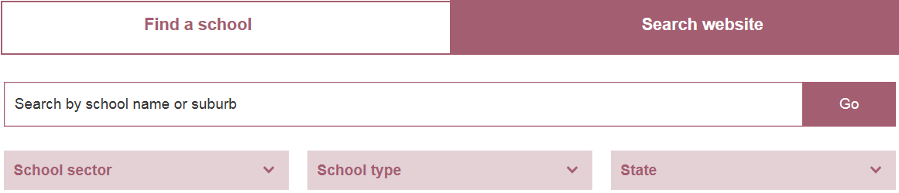

1. Click on ‘View School Profile’ of the appropriate school to access the school’s profile.



1. Click on ‘Finances’ and select the appropriate year to view the school financial information.



Note:

If you are unable to access the internet, please contact the school for a hard copy of the school’s financial information.

|  |
| --- |
| Our staff profile |
|  |

Workforce composition

Staff composition, including Indigenous staff

Table 8: Workforce composition for this school

| Description | Teaching staff* | Non-teaching staff | Indigenous** staff |
| --- | --- | --- | --- |
| Headcounts | 68 | 38 | <5 |
| Full-time equivalents | 63 | 27 | <5 |
| *Teaching staff includes School Leaders.  ** *Indigenous* refers to Aboriginal and Torres Strait Islander people of Australia. | | | |

Qualification of all teachers

Table 9: Teacher qualifications for classroom teachers and school leaders at this school

| Highest level of qualification | Number of qualifications | *Graduate Diploma etc. includes Graduate Diploma, Bachelor Honours Degree, and Graduate Certificate. |
| --- | --- | --- |
| Masters | 2 |
| Graduate Diploma etc.* | 25 |
| Bachelor degree | 41 |

Professional development

Expenditure on and teacher participation in professional development

The total funds expended on teacher professional development in 2018 were $102, 510.

The major professional development initiatives are as follows:

* Reading
* Writing
* Coaching
* Leadership
* Age Appropriate Pedagogies
* Australian Curriculum

The proportion of the teaching staff involved in professional development activities during 2018 was 100%

Staff attendance and retention

Staff attendance

Table 10: Average staff attendance for this school as percentages

| Description | 2016 | 2017 | 2018 |
| --- | --- | --- | --- |
| Staff attendance for permanent and temporary staff and school leaders. | 96% | 95% | 95% |

Proportion of staff retained from the previous school year

From the end of the previous school year, 95% of staff were retained by the school for the entire 2018.

|  |
| --- |
| Performance of our students |
|  |

Key student outcomes

Student attendance

The overall student attendance rate in 2018 for all Queensland state Primary schools was 92%.

Tables 11–12 show attendance rates at this school as percentages.

Table 11: Overall student attendance at this school

|  |  |  |  |
| --- | --- | --- | --- |
| Description | 2016 | 2017 | 2018 |
| Overall attendance rate* for students at this school | 92% | 93% | 92% |
| Attendance rate for Indigenous** students at this school | 90% | 93% | 92% |
| * Student attendance rate = the total of full-days and part-days that students attended divided by the total of all possible days for students to attend (expressed as a percentage).  ** *Indigenous* refers to Aboriginal and Torres Strait Islander people of Australia. | | | |

Table 12: Average student attendance rates for each year level at this school

| Year level | 2016 | 2017 | 2018 |  | Year level | 2016 | 2017 | 2018 | Notes:  1. Attendance rates effectively count attendance for every student for every day of attendance in Semester 1.  2. Student attendance rate = the total of full-days and part-days that students attended divided by the total of all possible days for students to attend (expressed as a percentage).  3. DW = Data withheld to ensure confidentiality. |
| --- | --- | --- | --- | --- | --- | --- | --- | --- | --- |
| Prep | 92% | 93% | 92% |  | Year 7 |  |  |  |
| Year 1 | 92% | 91% | 90% |  | Year 8 |  |  |  |
| Year 2 | 92% | 93% | 92% |  | Year 9 |  |  |  |
| Year 3 | 92% | 92% | 92% |  | Year 10 |  |  |  |
| Year 4 | 94% | 93% | 91% |  | Year 11 |  |  |  |
| Year 5 | 93% | 94% | 92% |  | Year 12 |  |  |  |
| Year 6 | 92% | 93% | 92% |  |  |  |  |  |

Student attendance distribution

Graph 1: Proportion of students by attendance rate



Description of how this school manages non-attendance

Queensland state schools manage non-attendance in line with the Queensland Department of Education procedures: [*Managing Student Absences and Enforcing Enrolment and Attendance at State Schools*](http://ppr.det.qld.gov.au/education/management/Pages/Managing-Student-Absences-and-Enforcing-Enrolment-and-Attendance-at-State-Schools.aspx); and [*Roll Marking in State Schools*](http://ppr.det.qld.gov.au/education/management/Pages/Roll-Marking-in-State-Schools.aspx)*,* which outline processes for managing and recording student attendance and absenteeism.

We are proactive in working with families to manage non-attendance. Our belief is that it is better to communicate our concerns early so a positive resolution as far as a solution to lack of regular attendance is reached. Non-attendance is managed in state schools in line with the DET policies, SMSPR-029: Managing Student Absences and SMS-PR-036: Roll Marking at Pacific Pines Primary records all student attendance and absenteeism during the morning and afternoon of each school day. Parents must apply in writing to the Principal for student extended absences. When students are late or need to leave early, parents sign them in or out with an explanation. Continued and regular late arrivals/early departures are followed up with parents/carers. Unauthorized attendance at school is taken very seriously and the school employs a series of measures, such as letters for unexplained absences, phone calls home and following protocol for continued absences from school. In serious cases of school refusal and absenteeism, the school seeks guidance officer and behaviour specialist support to work with the school and with families. Parents are reminded of school attendance on a regular basis through newsletters and assemblies.

Through our same day notification processes, parents are sent text messages daily if students are absent without explanation.

Rewards are offered each term to classes with the highest attendance. Student who have 100% attendance each term receive a Principal’s Certificate of recognition. Attendance data is also a major focus of our end of term whole school celebration assemblies.

NAPLAN

Our reading, writing, spelling, grammar and punctuation, and numeracy results for the Years 3, 5, 7 and 9 NAPLAN tests are available via the [*My School*](http://www.myschool.edu.au/) website.

How to access our NAPLAN results

1. Click on the *My School* link <http://www.myschool.edu.au/>.
2. Enter the school name or suburb of the school you wish to search.



1. Click on ‘View School Profile’ of the appropriate school to access the school’s profile.



1. Click on ‘NAPLAN’ to access the school NAPLAN information.



Notes:

1. If you are unable to access the internet, please contact the school for a hard copy of the school’s NAPLAN results.

2. The National Assessment Program – Literacy and Numeracy ([NAPLAN](http://www.nap.edu.au/naplan)) is an annual assessment for students in Years 3, 5, 7 and 9.